MSBA Server Lab

Team 1 (Andrea Ayala, Patty Kingery, Bryce Williams, Miguel Garcia, Patrick Grodach)

6/8/2024

Methodology

In this lab, we used AWS EC2 to make a virtual server in the cloud. We set up an EC2 instance with key features like using Microsoft Windows Server 2022, picking a small instance size (t2.micro) for basic workloads, adjusting storage, and turning on detailed monitoring for better performance tracking. We also made a new key pair and saved it for future use. The .pem file made from this gives us the password to access the instance.

Once the EC2 instance was created, we assigned an elastic IP address to the server so whenever it is accessed, the IP address remains the same. This is crucial for scenarios where you need a consistent IP address, such as hosting a website. It also helps avoid the need to update DNS records frequently.

Before accessing the server, we had to go back to the instance page and collect the DNS name of the server and the password for the server. For the admin password, we used the private key file created earlier to upload into AWS and decrypt the password. If you lose access to your instance due to a missing .pem file, recovering access can be challenging and may involve creating a new instance or attempting to reset the instance's credentials, which can be time-consuming and may result in data loss. Now that we have the DNS name and password, we can open Remote Desktop Connection and login to our server. Once ready, we were able to see a Windows desktop as expected.

We then had to configure our server as a web server which can be used to serve web pages to users over the internet. We then were able to access the local web server installed on the server. To personalize the web page, we created a simple HTML file, including an image. This HTML file had to be saved in the C:\inetpub\wwwroot\ folder because it serves as the root directory for websites hosted on the server. Files stored in that folder make up the website. We were then able to edit the HTML file to include a picture of our own as seen below:

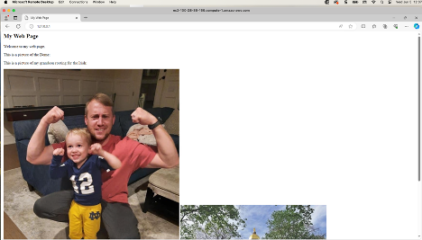

At this point, our website wasn’t publicly available outside of the server because the security groups applied on this server did not allow this access. By configuring HTTP and HTTPS inbound rules, we specify which incoming connections are allowed to reach our web server, therefore making the website available outside of the server as seen below:



When there are a number of people accessing a server or there are too many things going on at once in a server, CPU utilization will increase. Because we don’t want any issues arising with CPU utilization on a server, we created an email alert to let us know when the average CPU utilization exceeded 75% for a single five-minute period. Other possible alarm actions included recover, reboot, stop, and terminate the server when passing the set threshold. CloudWatch in AWS allows us to verify that the alarm was created. To test the email alert, we created a batch script to simulate real activity on the server. About 5 minutes after running the batch script, we got the following email alert:

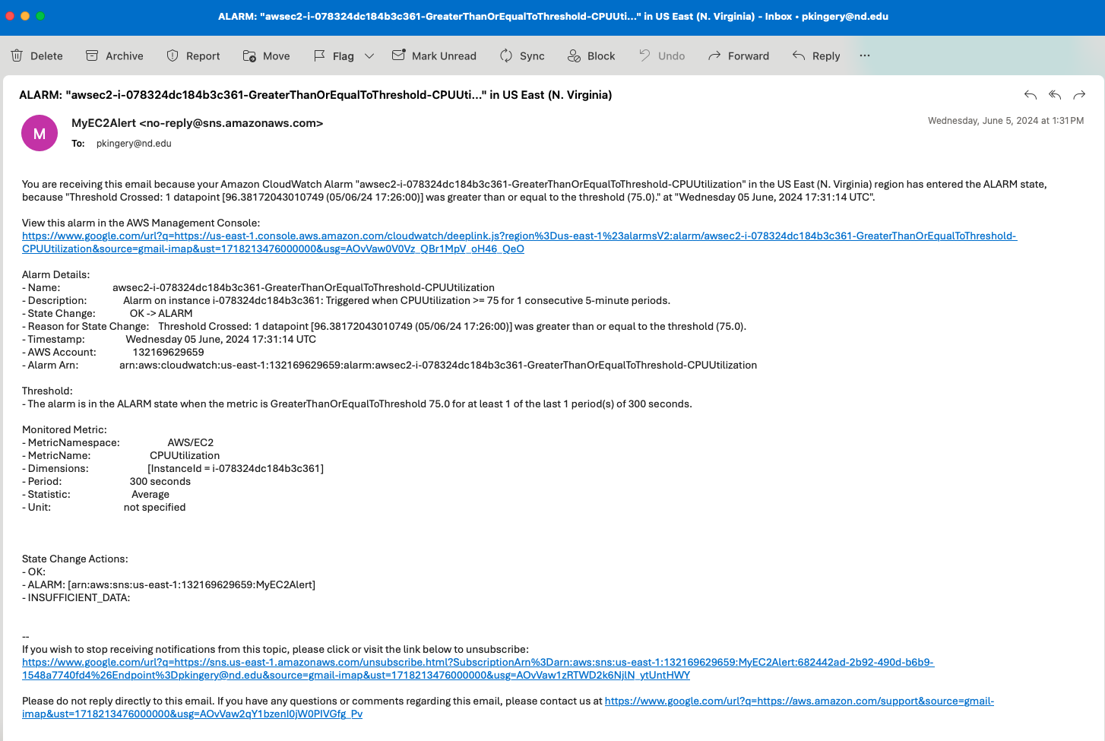

There are other ways we can track server performance. CloudWatch provides server metrics from a CPU, disk, and networking perspective. Here is a glance at the CPU utilization of the server that we created. We can see the batch script very quickly utilized a majority of the CPU available in the server.

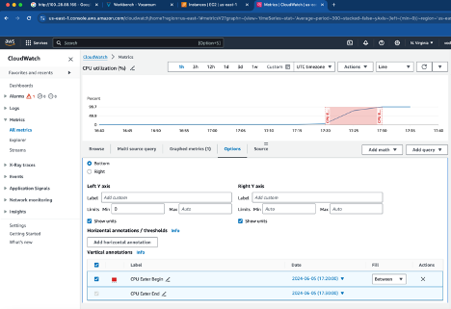

**Analysis**

Section A:

Instance Type: t2. micro

Monthly Cost Calculation:

* Instance Cost:
  + On-Demand Hourly Rate: Approximately $0.0196 per hour
  + Hours in a Month: 720 hours (30 days * 24 hours/day)
  + Monthly Instance Cost: $1.744 * 720 = $14.112
* EBS Volume Cost:
  + Volume Size: 2 TB = 2000 GiB
  + Cost per GiB-month for gp2: $0.10 per GiB-month
  + EBS Monthly Cost: 30 GiB * $0.10 = $3.00
* Elastic IP Cost:
  + Associated with Running Instance: Free

Total Monthly Cost:

* Total: $14.112 (Instance) + $3.00 (EBS) = $17.112

Summary:

* The total monthly cost for the t2.micro EC2 instance running continuously in the Northern Virginia region, including the server instance costs and EBS volume cost (assuming 30 GiB), is $17.11.

Section B: Windows Application Server

Instance Requirements:

* Memory: At least 50 GB
* vCPUs: At least 8
* Disk Space: 2 TB
* Elastic IP Address

Instance Type Selection:

* Instance Type: r5.4xlarge
  + Specifications: 16 vCPUs, 128 GiB memory
  + Reasoning: Chosen for its ample memory and vCPU capacity, meeting the application's requirements efficiently.

Monthly Cost Calculation:

* Instance Cost:
  + On-Demand Hourly Rate: Approximately $1.744 per hour
  + Hours in a Month: 720 hours (30 days * 24 hours/day)
  + Monthly Instance Cost: $1.744 * 720 = $1255.68
* EBS Volume Cost:
  + Volume Size: 2 TB = 2000 GiB
  + Cost per GiB-month for gp2: $0.10 per GiB-month
  + EBS Monthly Cost: 2000 GiB * $0.10 = $200.00
* Elastic IP Cost:
  + Associated with Running Instance: Free

Total Monthly Cost:

* Total: $1255.68 (Instance) + $200.00 (EBS) = $1455.68

Summary:

* The r5.4xlarge instance type is chosen for its robust performance capabilities, ensuring the Windows application server meets operational requirements effectively. The total monthly cost, including EBS storage and an elastic IP address, is $1455.68

Section C: Linux Web Server

Instance Requirements:

* Memory: 1 GB (typically used, occasional need for 4 GB)
* vCPUs: 1 (typically used, occasional need for 2)
* Disk Space: 20 GB
* Elastic IP Address

Instance Type Selection:

* Instance Type: t3a.medium
  + Specifications: 2 vCPUs, 8 GiB memory (baseline, burstable to handle occasional spikes)
  + Reasoning: Balances cost-effectiveness with burstable performance, suitable for variable workload patterns.

Monthly Cost Calculation:

* Instance Cost:
  + On-Demand Hourly Rate: Approximately $0.0416 per hour
  + Hours in a Month: 720 hours (30 days * 24 hours/day)
  + Monthly Instance Cost: $0.0416 * 720 = $29.952
* EBS Volume Cost:
  + Volume Size: 20 GB
  + Cost per GiB-month for gp2: $0.10 per GiB-month
  + EBS Monthly Cost: 20 GiB * $0.10 = $2.00
* Elastic IP Cost:
  + Associated with Running Instance: Free

Total Monthly Cost:

* Total: $29.952 (Instance) + $2.00 (EBS) = $31.952

Summary:

* The t3a.medium instance type is selected for its ability to handle both typical low-resource usage and occasional bursts, aligning with the Linux web server's variable workload requirements. The total monthly cost, including EBS storage and an elastic IP address, is $31.95.